Class Assignment 20/05/26
Q1. Read the text given below.

ChatGPT has been gaining attention for how closely it mimics human-like responses. Created by OpenAI in 2022, it is a chatbot that has been trained to have knowledge of worldly events and phenomena up till September 2021 and to interpret the context of texts to produce meaningful responses. The tool can provide answers on many topics, and often states disclaimers if it cannot answer a prompt accurately. Unlike a search engine, it cannot browse the internet for information. It also does not collect any personal information of users.
A survey was administered to understand the uses of ChatGPT in the fields of education,
healthcare and research. There were 420 participants in the study of which 59 respondents were from the medical field, 118 respondents were students and faculty from the research field, 70 respondents identified as administrative staff, and 173 people marked 'other' as their occupation. Of the 420 respondents, only 40% had used ChatGPT before. More medical trainees and students as well as research students had used ChatGPT as compared to medical staff and research faculty.
The survey asked about the viability of ChatGPT for its use within the fields of education, research, and healthcare. The following table summarises the responses.

Question | Statement |  |  |  | Number of respondents
Should ChatGPT be used in Education? | No, it should | be banned. |  |  | 11
Should ChatGPT be used in Education? | I don't know; it is too early to make a statement. |  |  |  | 226
Should ChatGPT be used in Education? | Yes, it should be actively incorporated. |  |  |  | 183
 | No, it should not be used at all. |  |  |  | 6
 | I don't know; it is too early to make a |  |  |  | 75
Should | statement. |  |  |  | 75
Should |  |  |  |  | 68
ChatGPT be | Yes, but it | should | only | be used to | 68
used in | brainstorm. |  |  |  | 68
Research?
Research? | Yes, as long as its use is transparently |  |  |  | 259
 | disclosed. |  |  |  | 259
 | Yes, disclosure is NOT needed. |  |  |  | 10
 | No, it should not be used at all. |  |  |  | 15
 | I don't know; it is too early to make a |  |  |  | 177
Should | statement. |  |  |  | 177
ChatGPT be | Yes, it can be used for administrat ive |  |  |  | 176
used in Healthcare? | purposes. |  |  |  | 176
used in Healthcare? | Yes, it can be used for any purpose. |  |  |  | 51

Based on the responses, there was a greater uncertainty around its use in healthcare and education, compared to using it in research. Regarding the use of ChatGPT in healthcare, a significant portion of respondents (42%) approved of using it for administra tive purposes (for example, preparing patient profiles or reports) and a smaller population of respondents (12.2%) felt it could be used for any purpose.
The current application of ChatGPT and its future potential needs to be examined. It can help students understand texts and write more effectively, simplify medical information for patients and automate administrative tasks, and prepare a summary of information which otherwise would require hours of reading through various resources. However, its negative impact must also be considered before institutions approve its use. - Multiple Authors
Source (edited): 'An exploratory survey about using ChatGPT in education, healthcare, and research' - https://www.medrxiv.org/content/10.1101/2023.03.31.23287979v1.full (330 words)

Answer the following questions, based on the passage above.
i Complete the given sentence in ONE word.
Based on the summary table, the_______number of respondents think that ChatGPT should not be used. 1
Ii The following was a prompt posted by a user in ChatGPT as their first question:
'What's my name?'
Based on information from the passage, which of these is most likely to be ChatGPT's response?
A. 'Error 404: page not found.' B. 'Your name is user 1000004.'
C. 'Sorry, can you repeat the question?' D. 'Sorry, I don't have access to your data.' 1
iii Imagine that you have to write a news report on a major landslide that occurred in Manipur on 30 June, 2022. Would using only ChatGPT be useful for your project? State why or why not in 40 words. 2
iv The following are the profiles of some respondents from the survey. Based on the passage, which of these profiles is MOST LIKELY to be a part of the 40% who have used ChatGPT before?
A. a manager in a hospital who has done 5 years of administrative work
B. a professor of Psychology who has 30 years of teaching experience
C. a college graduate who is studying in a 2-year Master's course
D. a 25-year-old teacher who is working in a public school 1
v Which of these is true about the respondents of the survey?
A. It had 118 respondents who were employed in the field of education.
B. It had 70 respondents who had administrative roles in educational institutions.
C. It had 173 respondents who were working in the field of research including students.
D. It had 59 respondents who were from the medical field including those who study medicine. 1
vi Why do you think some respondents feel that ChatGPT should be banned in education? State a reason in 40 words. 2
vii Locate a detail from the passage that shows that we still do not know enough about ChatGPT. Answer in one sentence. 1
viii State TRUE or FALSE.
More than half of the respondents think it is ok to use ChatGPT in research if one clearly states its contribution. 1

2. Read the following carefully. The, answer the following questions, based on the given passage.

1 A recent survey was conducted among 2,000 college students and young professionals to analyse preferences for different types of jobs, including corporate roles, personal start-ups or family businesses, and service professions (example - defence, nursing, police). The study aimed to identify trends in career aspirations, the factors influencing these preferences, and their implications for workforce planning and education systems. Participants were asked to rank their preferences on a five-point scale.
2 The study covered respondents across urban and semi-urban areas, representing diverse educational, economic, and cultural backgrounds. Researchers ensured diversity in gender, socioeconomic status, and career stages to make the findings representative of a broad spectrum of opinions. Data collection involved online questionnaires and in-person interviews, ensuring a comprehensive understanding of job preferences. The data was displayed as a bar graph given below.

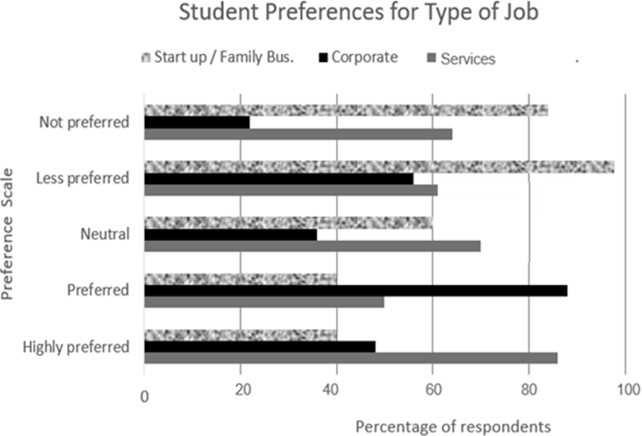

3 Corporate jobs were commonly associated with financial stability, growth opportunities, and access to structured career paths. Start-ups and family businesses, on the other hand, appealed to those valuing autonomy, creativity, and the chance to work in more flexible environments. Service professions were perceived as fulfilling and prestigious, especially among individuals motivated by a sense of duty.
4 The survey also highlighted several challenges. Geographic variations were significant, with urban respondents gravitating more toward corporate roles, while semi-urban participants showed a stronger inclination for service professions and family businesses. Respondents indicated limited mentorship opportunities and a lack of clarity about the long-term prospects of non-corporate careers as barriers influencing their decisions.
5 The findings provide a foundation for further research into how cultural, regional, and generational influences shape career choices. Future studies could explore factors such as gender-based preferences, emerging industries, mentorship availability, and the role of technological advancements in shaping job markets. Additionally, longitudinal research could track how these preferences evolve as respondents advance in their careers. This could help educational institutions and employers develop tailored strategies to better align with the aspirations and values of young job seekers. Moreover, policies encouraging skill development and mentorship programmes may bridge the gaps identified in this survey, ensuring more informed career decisions among youth.
Created for academic usage / 348 words 10

I. What was the main purpose of the survey conducted among 2,000 college students and young professionals?
A. To determine the popularity of specific jobs in rural areas versus urban areas
B. To explore patterns in career aspirations and the factors influencing them
C. To analyse the success rate of start-ups and family businesses
D. To assess the salary expectations of young professionals opting for jobs 1
II. Fill in the blank with the correct option from those given in brackets.
The study ensured diversity in gender, socioeconomic status, and career stages to make the findings (accurate / representative / specific). 1
III. Fill in the blank with reference to the given bar graph chart.
The profession preference for which policymakers primarily need to provide encouraging incentives is _______________________. 1
IV. Based on the bar graph, which of the following statements best reflects the correct trend in job preferences?
A. Corporate jobs are more in the ‘Least preferred’ category than service professions.
B. Service professions are less preferred than corporate jobs on the ‘Neutral’ scale.
C. Service professions have a higher percentage of respondents marking them as ‘Highly Preferred’ compared to corporate jobs.
D. Corporate jobs and service professions have an equal percentage of respondents marking them as ‘Preferred.’
V. Riya wishes to have a regular salary and defined growth in her career. Why is a corporate job better suited for her compared to joining a start-up or family business? (Ref: Paragraphs 3 & 4)
VI. When the researcher says ‘Respondents indicated limited mentorship opportunities,’ what does s/he mean by ‘limited mentorship opportunities’?
A. Lack of financial resources to hire mentors for jobs
B. Absence of training programmes in semi-urban areas
C. Reluctance of respondents to seek career advice from unknown people
D. Difficulty in finding experienced professionals to guide career paths (Ref: Paragraph 4)
VII. How might further studies in the understanding of emerging industries and technological advancements empower youth to make well-informed career decisions? (Ref: Paragraph 5)
VIII Select the option that is NOT addressed in this study.
A. The purpose of the survey B. The impact of gender on career preferences
C. Regional and demographic variations in preferences D. Challenges faced by respondents
E. The methodology used for data collection

